**Summary:**

The goal of this assignment was for the student to simulate a treasure chest game. This program tracks which chest the player found and updates a boolean array and displays the information to the player. There is also a token in one of the treasure chests that allows the player to progress to the next level. The token is assigned to a random element in the array and the program checks if the user’s choice matches that token to level up. Otherwise, the player continues to place each treasure found in the array via a loop. An additional requirement was to use pointers for this exercise to access each element of the array. Two functions were created to add each treasre chest in the treasure array and the other function was to display the entire inventory of chests. I decided to leave the display inventory feature in the program for debugging purposes and to inform the player in real time. Some of the errors I’ve experienced mainly involved logicals errors with the rand() function and the modulus operator. The treasureArray[rand() % 5] line was to access a random element in the array from indexes 0 to 5.

**Test Case for Chests: 5, 4, 3, 2**

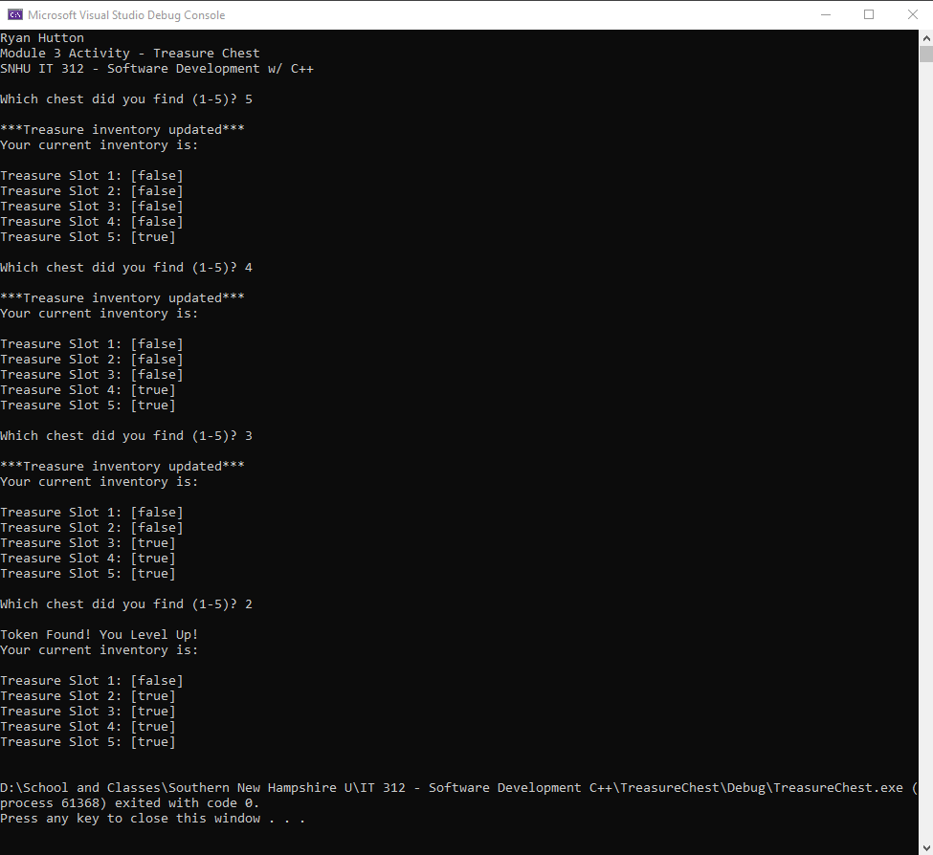

Code on last page.

